**Teacher Notes for**

“**Why and How Your Body Makes Millions of Red Blood Cells Every Minute**”[1]

In this activity, students learn about stem cells, cell differentiation, and how transcription factors contribute to cell differentiation. These concepts are introduced as students learn how the body makes red blood cells and answer multiple minds-on questions.

Before beginning this activity, students should have a basic understanding of mitosis and transcription and translation. For this purpose, you may want to use:

* the hands-on activity, “Mitosis – How a Single Cell Developed into the Trillions of Cells in a Human Body” (<https://serendipstudio.org/sci_edu/waldron/#mitosis>) or the analysis and discussion activity, “Mitosis and the Cell Cycle – How the Trillions of Cells in a Human Body Developed from a Single Cell” (<https://serendipstudio.org/exchange/bioactivities/MitosisRR>)[2]
* the hands-on activity, "From Gene to Protein – Transcription and Translation" (<https://serendipstudio.org/sci_edu/waldron/#trans>) or the analysis and discussion activity, "From Gene to Protein via Transcription and Translation (<https://serendipstudio.org/exchange/bioactivities/trans>).

**Learning Goals**

In accord with the Next Generation Science Standards[3]:

* + - * Students will gain understanding of the Disciplinary Core Idea LS1.B: Growth and Development of Organisms.
* “The organism begins as a single cell (fertilized egg) that divides successively to produce many cells, … Cellular division and differentiation produce and maintain a complex organism, …”
* Students will engage in the Scientific Practice:
* Constructing Explanations. “Apply scientific ideas, principles, and/or evidence to provide an explanation of phenomena…”
* This activity provides the opportunity to discuss the Crosscutting Concept:
* Cause and effect: Mechanism and explanation. Students “suggest cause and effect relationships to explain and predict behaviors in complex natural and designed systems”.
* This activity helps to prepare students for the Performance Expectation, HS-LS1-4:
* “Use a model to illustrate the role of cellular division (mitosis) and differentiation in producing and maintaining complex organisms."

**Instructional Suggestions and Background Biology**

To maximize student participation and learning, I suggest that you have your students work individually, in pairs, or in small groups to answer each group of related questions. After students have answered each group of questions, I suggest that you lead a class discussion of student answers to probe their thinking and guide them to a sound understanding of the concepts and information before moving on to the next group of questions.

You may want to revise the Word document to prepare a version of the Student Handout that will be more suitable for your students. If you use the Word document, please check the format by viewing the PDF. If your students are learning online, I recommend that they use the Google Doc version of the Student Handout, which is available at <https://serendipstudio.org/exchange/bioactivities/epigenetics>.

A key is available upon request to Ingrid Waldron ([iwaldron@upenn.edu](mailto:iwaldron@upenn.edu)). The following paragraphs provide background information which will be useful for your understanding and may be useful for responding to student questions.

Red blood cells are very well adapted to transport maximum oxygen. Each red blood cell contains roughly 250 million molecules of hemoglobin and little else except water. The absence of the nucleus, mitochondria and other organelles makes room for more hemoglobin, and the absence of mitochondria means that the oxygen carried by the red blood cell is not used for cellular respiration. The diameter of a red blood cell is about 7 µm (just small enough to fit through capillaries, which are 8-10 µm in diameter). Red blood cells are biconcave discs. The small size and disk shape maximize surface-area-to-volume ratio and facilitate rapid diffusion of oxygen into and out of the red blood cells.

For simplicity, the Student Handout focuses on production of hemoglobin polypeptides in adults and does not mention the following complexities.

* Hemoglobin contains four polypeptide chains, each of which contains a heme molecule.
* Both the amino acid sequence in the hemoglobin polypeptides and the location of hemoglobin synthesis differ at different stages of development.

|  |
| --- |
| Lecture Notes in Medical Technology: Lecture #4: Hemoglobin  (<https://mt-lectures.blogspot.com/2017/08/lecture-4-hemoglobin.html>) |

Question 1b compares the average 4-month lifespan of red blood cells with cells that have an average lifespan of more than a year (e.g. adipocytes, cardiomyocytes, other myocytes, and glial cells) (<https://www.nature.com/articles/s41591-020-01182-9>). The shorter lifespan of a red blood cell is related to its inability to repair itself, because it lacks a nucleus, ribosomes and mitochondria.[4]

The technical term for blood stem cells is hematopoietic stem cells. The descendants of hematopoietic stem cells develop into red blood cells, white blood cells (including phagocytic cells and lymphocytes), or megakaryocytes (which give rise to platelets). There are less than 200,000 hematopoietic stem cells in a human body. This number is obviously much smaller than the trillions of red blood cells in a human body or even the billions of red blood cells that a person makes in a day. The reason why a person doesn’t run out of hematopoietic stem cells is a general property of stem cells – when a hematopoietic stem cell divides, one of the daughter cells becomes a replacement hematopoietic stem cell (<https://stemcells.nih.gov/info/basics>). The other daughter cell undergoes multiple mitotic cell divisions, followed by differentiation.

Students should be able to answer question 3 by contrasting the characteristics of blood stem cells with the characteristics of red blood cells. Basic steps needed to convert blood stem cells to red blood cells are:

* getting rid of the nucleus and other organelles (question 6)
* making lots of hemoglobin (questions 7-9).

The recommended ~4-minute video, “Cell Differentiation” (<https://www.pearson.com/channels/biology/asset/f8063efc/cell-differentiation-genetics-biology-fuseschool>), provides a general introduction to stem cells and cell differentiation. During cell differentiation, cells acquire the specialized characteristics of a particular specialized type of cell.

The very brief review of transcription and translation in question 5 will remind students of the concepts they will need to understand and answer subsequent questions.

In the bone marrow, the developing red blood cell is next to a phagocytic cell, which ingests and digests the ejected nucleus.

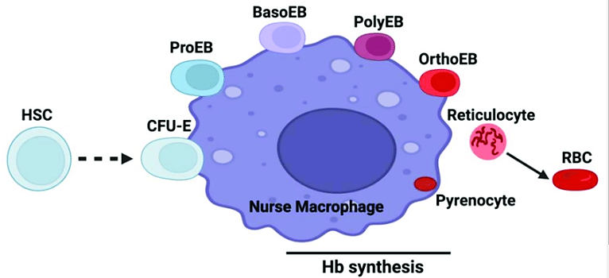

The production of red blood cells begins with an HSC (hematopoietic stem cell). The CFU-E (Colony Forming Unit-Erythroid) undergoes extensive cell division. After the ejection of the nucleus, the cell is called a reticulocyte; the reticulocyte moves into the bloodstream where it ejects other organelles to finish differentiating into a red blood cell.[5] The ejected nucleus with a small amount of cytoplasm is called a pyrenocyte; the pyrenocyte is taken up by the nurse macrophage (a type of phagocytic cell).

(<https://www.researchgate.net/figure/Erythroid-differentiation-in-the-context-of-the-erythroblastic-island-niche-The-diagram_fig1_361840792>)

Student answers to question 7 should be based on their understanding of mitosis (as well as the contents of the cell differentiation video).

|  |  |
| --- | --- |
| Transcription factors are proteins that initiate transcription and regulate the rate of transcription of genes. A single transcription factor often regulates the rate of transcription for multiple genes involved in the differentiation of a specific type of cell.[6]  The simplified figure in question 8 is appropriate for high school students. The figure on the right provides more information about the control of transcription. (In addition, this figure illustrates an alternate definition of a gene; in this definition, a gene includes only the coding region and excludes the promoter and other regulatory regions of the DNA.[7] ) | https://i2.wp.com/cms.jackwestin.com/wp-content/uploads/2020/03/Transcription-factor-binding.png?resize=921%2C1200&ssl=1 |

(<https://i2.wp.com/cms.jackwestin.com/wp-content/uploads/2020/03/Transcription-factor-binding.png?resize=921%2C1200&ssl=1>)

If you want to challenge your students, you can include the following question.

**9a**. Different transcription factors bind to the regulatory regions for different genes. The transcription factor that turns on transcription of the hemoglobin gene is found in cells that are developing into:

a. muscle cells

b. red blood cells

c. skin cells

d. all of these

**9b.** Explain your reasoning.

To help your students to understand why each DNA molecule is wound around histones in a human chromosome you may want to include the following information. If fully extended, the DNA in each human chromosome would extend approximately 2-8 cm. This is much longer than the ~0.001 cm diameter of a human nucleus (<https://www.ncbi.nlm.nih.gov/pmc/articles/PMC6391780/>).

The GATA-1 protein is a transcription factor that plays a major role in the differentiation of red blood cells. GATA-1 regulates the transcription of hundreds of genes that mediate the development of red blood cells. For example, GATA-1 stimulates acetylation of the histones that the hemoglobin gene is wound around. Specifically, GATA-1 activates histone acetyl transferase (HAT), an enzyme that acetylates lysine amino acids in the tails of local histones (see first figure below). This contributes to the more spread out structure of euchromatin (see second figure below; note that the second figure has a reverse left-to-right orientation, compared with the first figure). The euchromatin structure of the hemoglobin gene allows transcription.

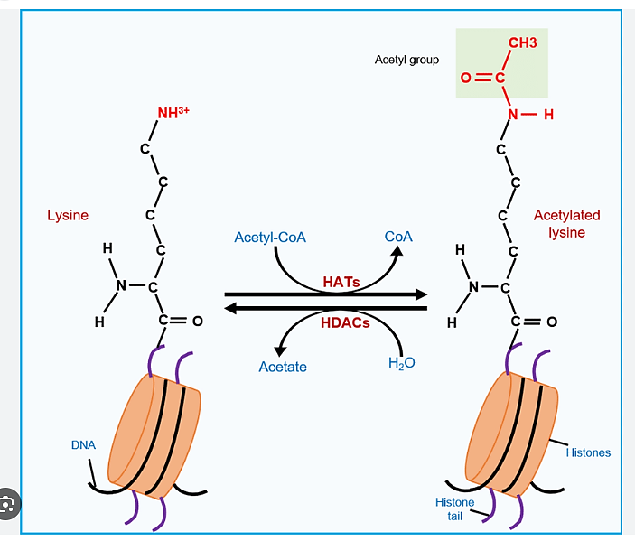

in histone tail

(<https://www.researchgate.net/publication/349664655/figure/fig2/AS:996051318214668@1614488548676/Regulation-of-histone-acetylation-dynamics-HATs-histone-acetyltransferases-transfer.png>)

|  |
| --- |
|  |

To avoid confusion, it should be noted that this figure has the opposite left-right orientation from the above figure.

(<https://www.researchgate.net/profile/Burcu-Biterge-Sut/publication/323913650/figure/fig1/AS:1026703971319812@1621796710909/The-conformational-transition-between-euchromatin-and-heterochromatin.png>)

The switch to euchromatin is an example of an epigenetic change that plays a role in the differentiation of red blood cells. If you want to include the concept of epigenetic changes in this activity you can add the following.

Epigenetic changes affect the rate of transcription of a gene by adding or removing side groups on the histones and/or the DNA of the gene. Epigenetic changes differ from mutations because epigenetic changes do *not* change the nucleotide sequence of the DNA. Epigenetic changes play a crucial role in cell differentiation.

**10**. What is an epigenetic change that contributes to the differentiation of red blood cells?

To help your students understand the term epigenetic, you may want to tell your students that “epi” is Greek for over, outside of, or around; this corresponds to the fact that epigenetic changes do not alter the sequence of nucleotides in the DNA. During differentiation of a red blood cell, one epigenetic change is increased acetylation of the histones in the region of the hemoglobin gene. “The most compelling definition of epigenetics is the study of changes in gene function that are heritable through cell division, yet reversible, and that do not involve changes in DNA sequence… Parent cells use epigenetic marks to “tell” their daughter cells what type of cell they will become … Epigenetic processes are fundamentally important for cell identity, lineage determination… They explain how an identical set of genomic instructions can generate all the required cell types for the organism without the need, in most cases, to alter gene sequence.” (<https://www.frontiersin.org/articles/10.3389/fcell.2018.00130/full>)

There are multiple interactions between transcription factors and epigenetic changes. For example, epigenetic mechanisms can help to start the transcription of genes that code for transcription factors.

Obviously, development involves much more than mitosis and cell differentiation. Information about other processes involved in development is available at:

* <http://www.scholarpedia.org/article/Morphogenesis>
* <http://www.healthofchildren.com/P/Prenatal-Development.html>
* <https://en.wikipedia.org/wiki/Prenatal_development>
* <https://www.youtube.com/watch?v=bEgygtbEo2A&feature=youtu.be>

**Sources for Figures in Student Handout**

* Figure that shows red blood cell, modified from <https://my.clevelandclinic.org/-/scassets/images/org/health/articles/21788-continuous-capillary-illustration>
* Figure that shows how blood stem cells give rise to red blood cells, constructed by the author
* Figure that shows transcription and translation, modified from Krogh, Biology – A Guide to the Natural World
* Figure that shows the effect of a transcription factor, modified from <https://www.sciencelearn.org.nz/images/957-transcription-factor-binding-to-dna>
* Figure that shows the effect of acetylation of histone proteins, modified from <https://rbej.biomedcentral.com/articles/10.1186/s12958-020-00637-5>

**Related Learning Activities**

"Molecular Biology: Major Concepts and Learning Activities" (<https://serendipstudio.org/exchange/bioactivities/MolBio>)

Topics covered include understanding the important roles of proteins and DNA, DNA structure and replication, the molecular biology of how genes influence traits (including transcription and translation), and the molecular biology of mutations and genetic engineering. To help students understand the relevance of these molecular processes, the suggested learning activities link alleles of specific genes to human characteristics such as albinism, sickle cell anemia and muscular dystrophy.

1. By Dr. Ingrid Waldron, Department of Biology, University of Pennsylvania, © 2024. These Teacher Notes and the related Student Handout are available at <https://serendipstudio.org/exchange/bioactivities/RedBloodCells>.
2. In these mitosis activities, students learn how mitosis ensures that each cell gets a complete set of chromosomes with a complete set of genes, and students are briefly introduced to cell differentiation.
3. Quotations from <https://www.nextgenscience.org/> and <https://www.nextgenscience.org/sites/default/files/HS%20LS%20topics%20combined%206.13.13.pdf>.
4. Many other cells that have a short lifespan are subjected to frequent physical or chemical stressors (e.g. skin cells or the cells that line the inside of the digestive tract).
5. For more information, you may want to show your students the first part or all of the 5-minute video, "Understanding Erythropoiesis" (<https://www.youtube.com/watch?v=cMqwV9Vb4_Y>).
6. A good introduction to transcription factors is <https://www.khanacademy.org/science/ap-biology/gene-expression-and-regulation/regulation-of-gene-expression-and-cell-specialization/a/eukaryotic-transcription-factors>. Gene expression is also regulated by mechanisms that act after transcription (<https://www.news-medical.net/life-sciences/Regulation-of-Gene-Expression.aspx>).
7. For a reference that uses the definition of a gene that is used in this activity, see <https://www.ncbi.nlm.nih.gov/books/NBK12983/#:~:text=The%20promoter%20(with%20or%20without,a%20linear%20polymer%20of%20nucleotides>.